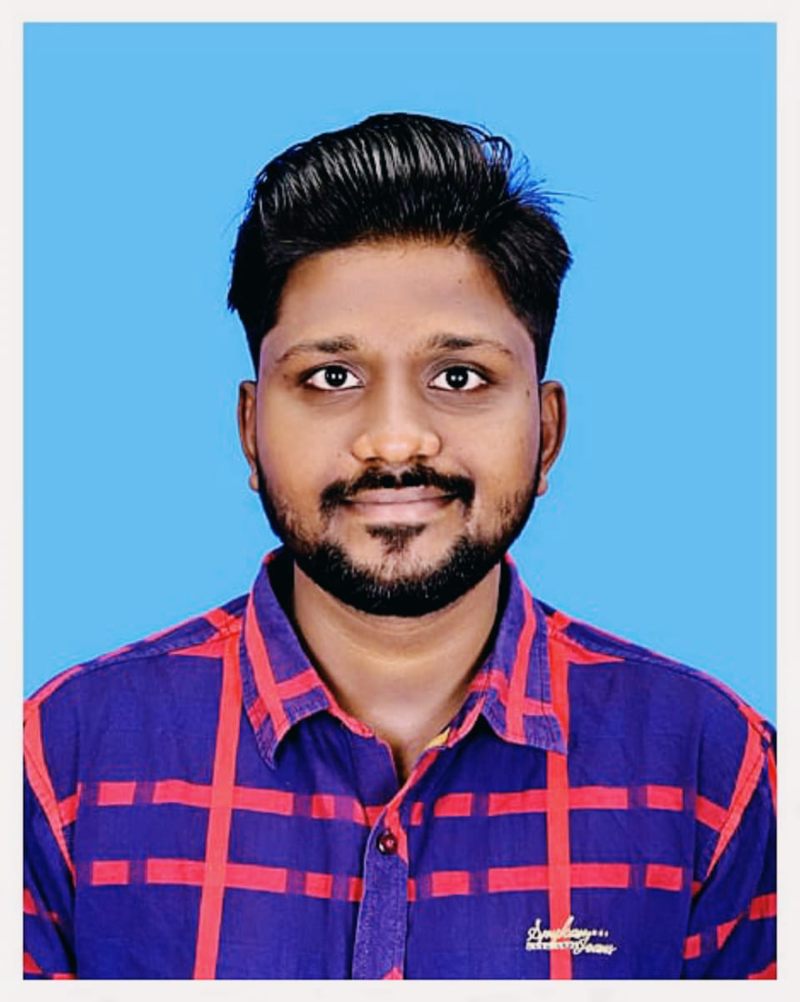**BLESSING V**

**BE, ECE**

**No 29, Municipality Rd,**

**Near ATSC theatre, Pollachi**

**[Mail: blessyb313@gmail.com](mailto:Mail:blessyb313@gmail.com)** **Ph no:9365687524**

**CAREER OBJECTIVE**

I seek challenging opportunities where I can fully use my skills for the success of the organization.

**EDUCATION DETAILS**

|  |  |  |  |
| --- | --- | --- | --- |
| **Course** | **Institution** | **Board/**  **University** | **Marks%/**  **CGPA** |
| **X** | Arokiamatha Matriculation School | TN State Board | 95.4% |
| **XII** | Tmt. Rukmaniammal Higher Secondary School | TN State Board | 75.33 |
| **B.E** | DR Mahalingam College of Engineering and Technology | Anna University,  Chennai | 8.56 |

**COURSES DONE**

* **Diploma in Computer Applications** course offered by CSC with **‘A Grade’**
* **PYTHON** course offered by CSC with **‘A Grade’**

**PROGRAMMING LANGUAGES KNOWN**

* C
* C++
* Python

**FIELDS OF INTEREST**

* Programming
* IOT
* Machine Learning

**INTERNSHIP**

Internship on **Computer Networking** in BSNL

**PROJECTS DONE**

**Mini Project – Flood Detection System Using** **IOT (Internet of Things)**

In this project, the objective is to sense the water levels at riverbeds and check whether they are at a normal condition or not. If they reach beyond the limit, then it alerts the people through LED indications as well as through internet application.

**Sign Language Recognition Using** **ML (Machine Learning)**

The objective of this project is to build a sign language interpreter using Machine learning technology. In this project we train a Convolutional Neural Network model using the collected sign language data and predict the sign language using the trained model.

**PERSONAL SKILLS**

* Good Listener
* Organizing Skills
* Leadership Quality
* Team Working

“I hereby declare that the information provided is true to the best of my knowledge and belief.”

**PLACE:**  **DATE:**  **(BLESSING V)**